Can I upload and share Microsoft Word and Excel files in Google Drive?
Yes! You can upload the file as is and will be able to share it but not make any changes to it. If you and your collaborators with whom you are sharing the file would like to also make changes to it then you will need to convert the file while uploading it. Here's how:
Uploading the file:
1. Open your Google Drive and click on the upload button and click file.
2. This will take you to the files you have stored on your computer.
3. Choose the file you want to upload, click open.
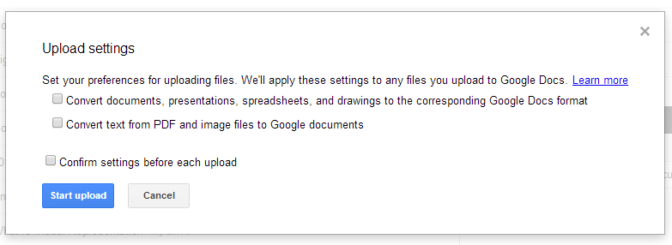
4. The Upload Settings box will appear. Mark the first box if you choose to convert the file so that you can make changes to it in Drive. (It is recommended that you also click the Confirm settings before each upload box. You also have the option to convert the file to a PDF.)
5. Once the file is uploaded and converted it will appear in your documents list with the Docs symbol . If you uploaded it without converting it, it will have the Word symbol next to it . You will not be able to edit the file in this format.

Sharing the file:
1. To share this uploaded and converted file with your collaborators click on the file to open it then click on the share button in the upper right.
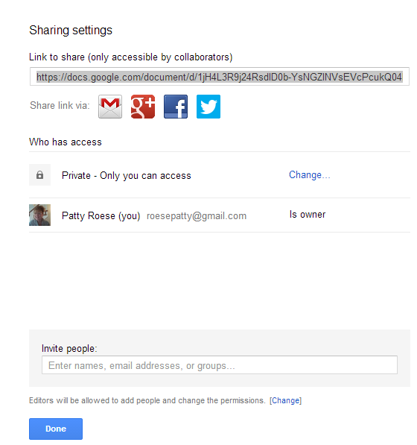
2. The Share Settings box will appear. Every Google Doc has its own address. This documents address appears here.
The default keeps the document private where only the owner has access to it. You can invite other people to view, comment on or edit this document by adding their email addresses. Once you add their addresses it will prompt you with choices to give them permission to comment or edit.

If you do not want those whom you have given permission to edit to then invite others to also make changes you need to click on change under the invite people box.
You can also give access to anyone with the link or even make it public on the web by clicking on change next to Private – Only you can access.

